
Phone 850 5020 Address: Cnr Dominion Road & Breckons Ave, Nawton
W:www.goodnewscommunitycentre.com E: info@goodnewscommunitycentre.com
Like us on Facebook “Good News Community Centre


September 2025
Spring has arrived and we look forward to the warmer weather. We have lots of exciting events, workshops and programmes coming up in the next few weeks including during the school holidays. Be sure to check inside for; event details to celebrate Te Wiki o Te Reo Māori at the centre, new cooked meals available for seniors, info session on gambling harm and a great range of our regular programmes and services.

September is Wills month.
Every adult with more than $15,000 of assets (including savings, KiwiSaver, and material assets) should have a will. Having a will is an important part of being an adult - like having insurance, or KiwiSaver. It's especially important if your KiwiSaver holds $15,000 or more, if you have kids, or a house.
And once you have a Will, make sure you review it and update it when things change in your life. Anyone who is of sound mind and is aged 18 or older can make a will. It is important to have a will so the people you care about most may be looked after, and it could take a long time and cost a lot of money to resolve matters if no will is in place. This could cause extra distress for your loved ones, during their time of grief.
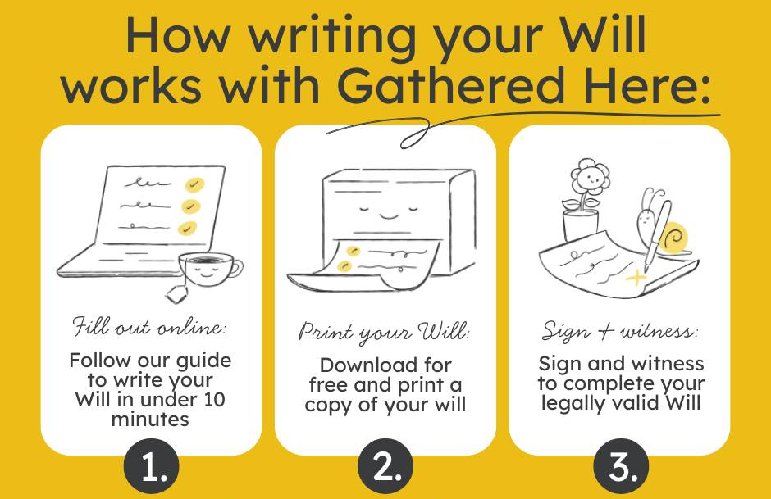
Been thinking you must write or update a will? Well you're in luck this month as part of wills month, we have partnered with Gathered Here to enable you to write your will for free! To find out more head to gatheredhere.com/nz/c/goodnews. Printing can be done at the Centre.
You also have an opportunity after taking care of family and friends to consider leaving a gift in your will to Te Rongopai Community Trust to support us to continue to serve the community for many years to come. Writing your will can help you to consider the legacy (long lasting impact) you will leave.


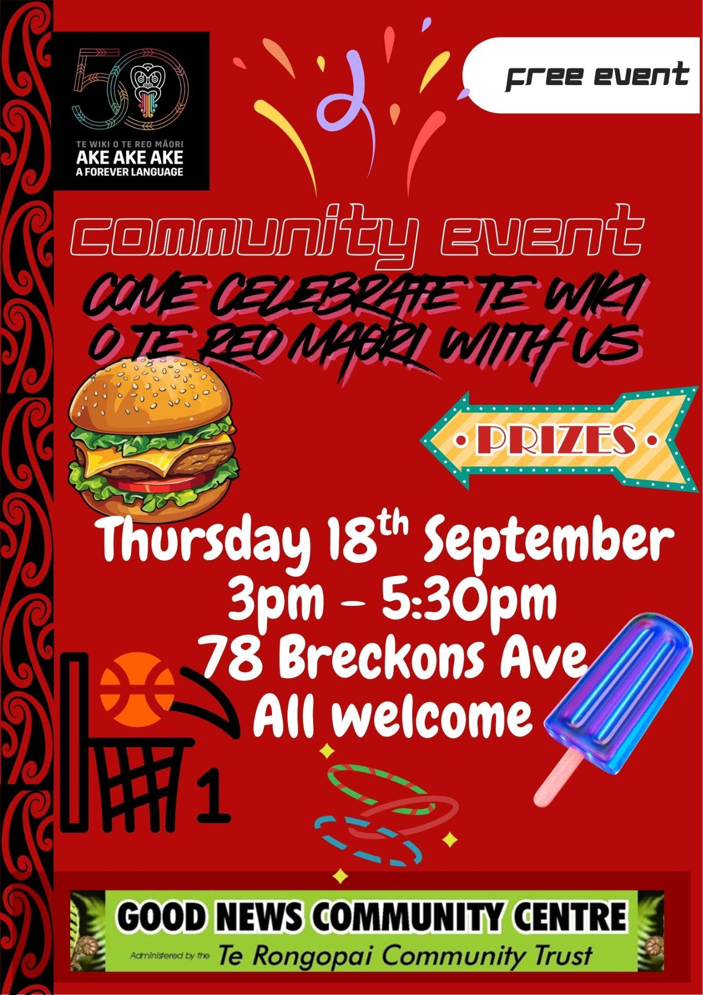
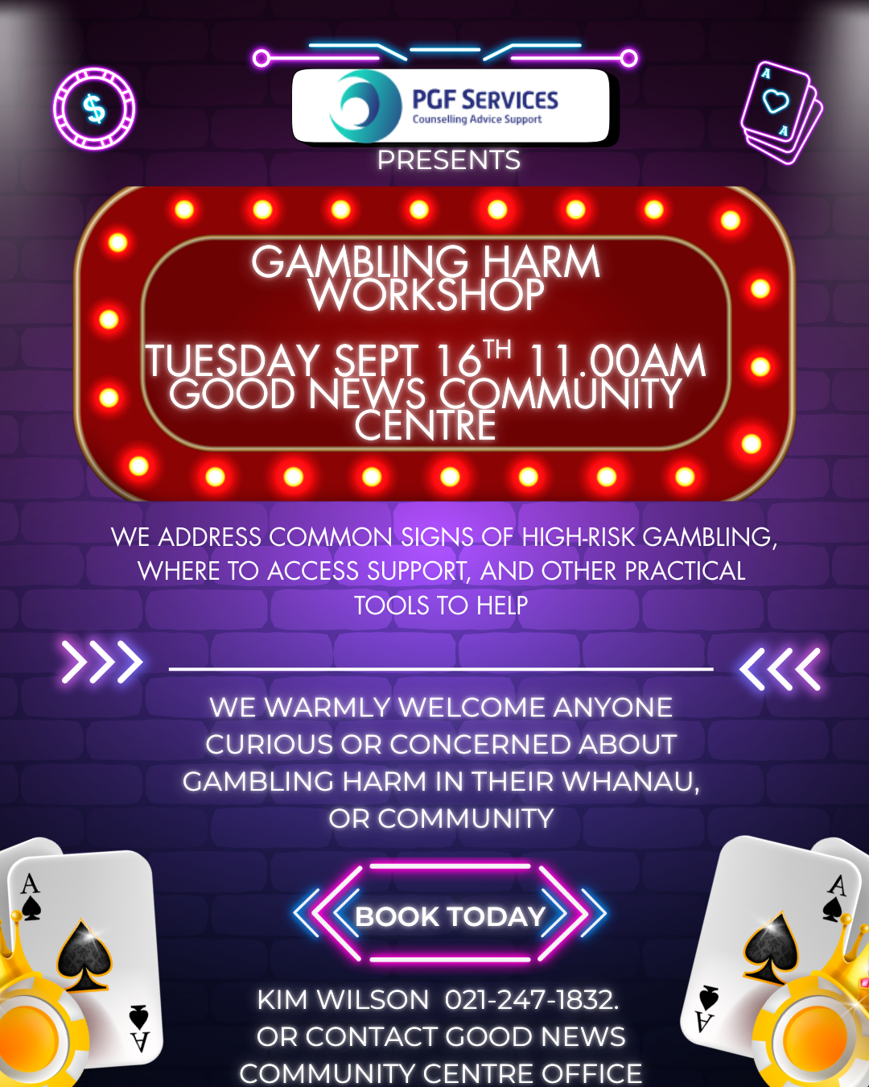
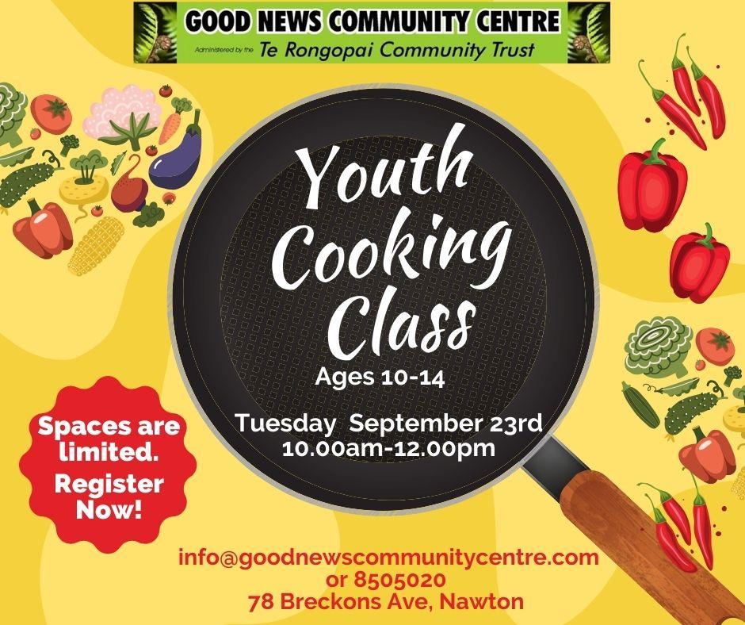
A new community partnership has been launched.

We have food parcels available that are already cooked meals. Do you know a senior or kaumatua in our community who is finding it hard to make ends meet? They can apply through us or directly to the heretohelpu.nz and request for food pick up from our community centre. They apply once for 8 parcels which could be spread out weekly or fortnightly.

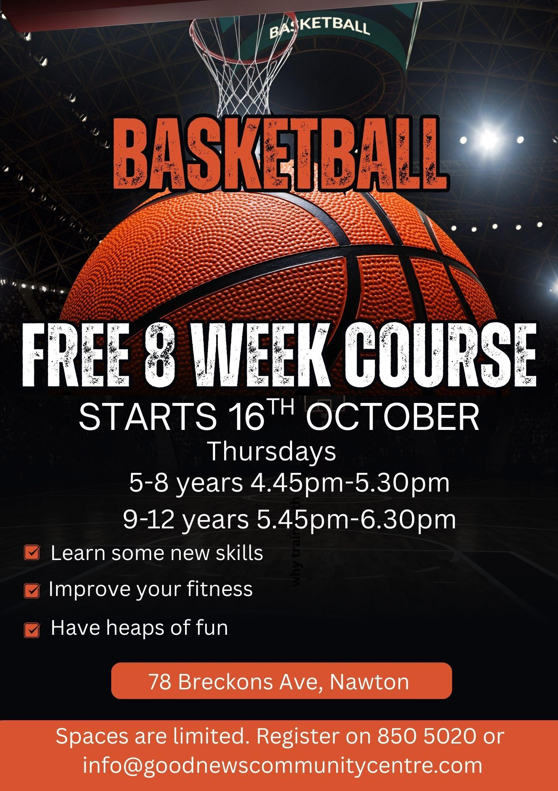
Weekly Schedule for Term 4, 2025.
Monday | Te Reo Maaori | 5.30pm-7.00pm
 | Hip Hop with Wai - free fitness class | 7.15pm-8.00pm
Tuesday | Golden Agers 65+  (2nd & 4th Tuesday of the month) | 10.00am-12.00pm
 | Moving Psalms (Gentle exercise & mediation) | 1:30pm-2:30pm
 | St Marks Afterschool Club | 3.00pm-4.30pm
 | Circuit Class with Josh - free fitness class | 5.15pm-6.00pm
Wednesday | The Hub | 3.00pm - 4:30pm
Thursday | The Hub | 3.00pm - 4:30pm
 | Basketball Ages 5-8 | 4.45pm - 5.30pm
 | Basketball Ages 9-12 | 5.45pm - 6.30pm
 | St Marks Youth Group | 7.00pm - 9.00pm
Friday | Box Fit with Isaiah - free fitness class | 10.00am - 10.45am
Sunday | St Marks Church with Children’s Church | 9:30am – 11.00am
 | Whanau Afternoons | 3:30pm - 5:30pm

OFFICE HOURS: Monday to Friday 9:30am - 2:30pm excluding public holidays.
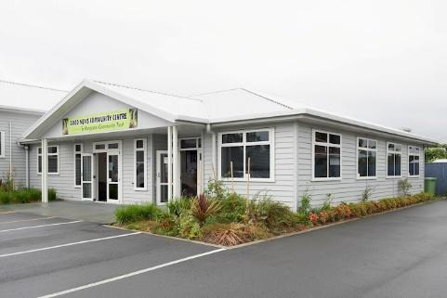
- Printing, wifi and scanning available.Food Parcel Service – Pick Up Days are Wednesday and Fridays. Enquire to the office.
- Free Kai Store: Mon, Tue, Thur, Fri 12:50pm
- Youth Mentoring - contact us to find out more.
Venue available for hire. Large hall, meeting rooms, great kitchen. Enquire now to avoid disappointment. Terms and Conditions apply.

